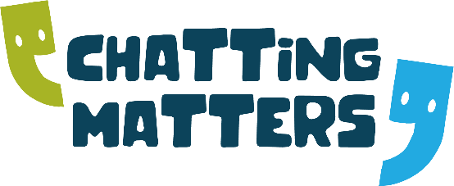
PA Employer Peer Mentor Meetings 2023
(Every Month, Wednesday 1-2pm)

DATES

18TH JANUARY 2023
15TH FEBRUARY 2023
15TH MARCH 2023
12TH APRIL 2023
17TH MAY 2023
14TH JUNE 2023
19TH JULY 2023
16TH AUGUST 2023
13TH SEPTEMBER 2023
18TH OCTOBER 2023
15TH NOVEMBER 2023
13TH DECEMBER 2023

For the zoom link, please contact either sharon@ailn.org
Tel: 07771 746604 or claire@ailn.org Tel: 07774490463

