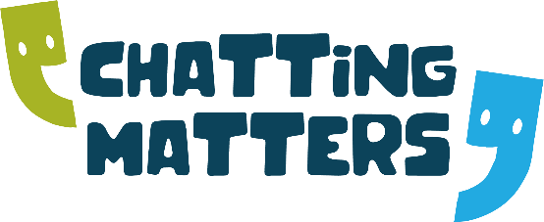
DATES FOR YOUR DIARY!
Peer/PA Mentor Meetings 2022
(Every Month, Wednesday 1-2pm)

DATES

29th June
20th July
17th August
21st September
19th October
16th November
21st December

Contact: sharon@ailn.org Tel: 07771 746604 or
claire@ailn.org Tel: 07774490463

