Dear Personal Assistant Employer
As an employer the information listed below is to keep you up to date with information to keep you and your staff safe
Re: Coronavirus (COVID-19)
The risk of catching coronavirus (COVID-19) in workplaces is currently low. Symptoms of the virus include a fever and a high temperature, which can develop into a cough, which leads to shortness of breath. These symptoms do not necessarily mean you have the illness. The symptoms are similar to other illnesses that are much more common, such as cold and flu.
To reduce the risk of the coronavirus we would like everyone to follow simple hygiene rules:
- Please ensure that you wash your hands with hot water and soap and also regular use of hand sanitisers
- It is important that you use tissues when sneezing or coughing and immediately dispose of them in the bin.

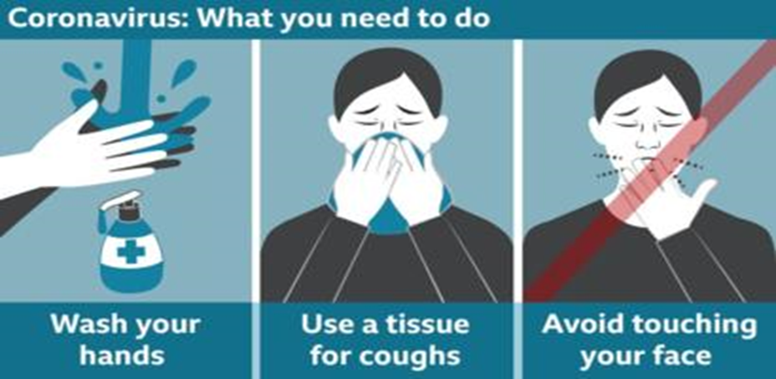

If you have been travelling and on your return to work are showing symptoms of the virus, please inform your Line Manager and they will advise you whether to attend work or put in measures for you to be able to work from home.

Information for Personal Assistants:
If you are unwell and unable to attend work, please follow your employer’s absence reporting procedure. This will be treated as sick leave and follow the usual sick pay policy, however if you have a genuine concern that it may be coronavirus and can provide a doctor’s note confirming that you were suffering with flu-like symptoms then your employer will still pay you your statutory sick pay if you qualify for that duration, from day 1.
We are seeking to ensure we limit the exposure and transmission of the virus.
If you become unwell in the workplace and have recently come back from an area affected by coronavirus, you should stay at least 2 metres (7 feet) away from other people, taking the following measures to limit risk of spread:
- Avoid touching anything
- When coughing or sneezing please do so into a tissue and put it in a bin, or if you don’t have tissues, cough and sneeze into the crook of your elbow instead of your hand.
- Immediately inform your line manager / Employer and leave the building.
- You must then phone NHS advice: 111 for an ambulance, if you’re seriously ill or injured or your life is at risk call 999. Ensure you tell the operator your symptoms which country you’ve returned from in the last 14 days.
- It is important that you communicate with your employer while you’re absent from work updating them on your condition so they can make the necessary steps within the workplace to ensure colleagues safety.

Please also see useful links below for more information:

https://www.acas.org.uk/coronavirus

https://www.gov.uk/government/news/sick-pay-from-day-one-for-those-affected-by-coronavirus

https://www.careinspectorate.com/index.php/coronavirus-professionals
https://www.nhsinform.scot/illnesses-and-conditions/infections-and-poisoning/coronavirus-covid-19

